1. **Background** – This website will be a portfolio for the work of Hunter Clark. Hunter is a current student at Wake Tech that is on his way to finishing his degree for Web Development. Up to this point he has created several websites that show off his skills and talents in the subject. He also has prior experience in CRM email campaign design and implementation. He needed a way to showcase his work so that he can secure a job or internship either during or after his college time.
2. **Goals**
   1. The goal of this site is to show off Hunter Clark’s portfolio.
   2. The intended audience of this site are his teacher and future employers.
   3. I will use a mix of HTML5 and CSS3 to build the website. I will be utilizing CSS Grid to provide a nice clean layout. I will also use various online sites to help pick a professional color scheme to match the aesthetics of the site.
   4. It should take about two weeks to complete.
   5. I would charge the client $500 dollars since there is no Javascript or e-commerce integration required for this.
   6. People will come to this site because it will look professional and clean. This will give them a positive experience in their search for Hunter’s work, which will hopefully turn the tables in his favor.
   7. My site will be viewed by HR professionals and my professor at their desks.
3. Audience
   1. My average visitor will be an HR representative or a fellow academic.
   2. They will use my site to ascertain what level my work is at.
   3. Their goals and objectives are as follows: “Is his work up to snuff?” / “Should we hire him?” / “What grade should I give him?”
   4. For this website they will be using mostly desktop to view it.
4. 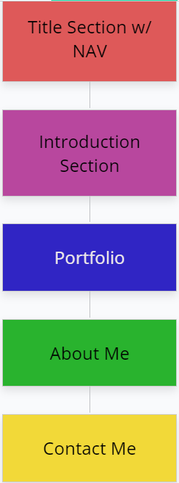
   1. Content
      1. My site will require an introduction paragraph, a grid for a gallery of portfolio projects with links, an about me section with picture and paragraph, a contact me section with a form, and a section with social media links and copyright warning.
      2. Required Content and Explanation
         1. Introduction Section – This section will have an intro paragraph about me and an image to go with it.
         2. Portfolio – I will be using CSS grid to make a gallery that shows off my portfolio of work. This will use screenshots of the index pages of these sites and corresponding links so that the viewer can than view the sites in question.
         3. About Me – This section will contain another picture of myself, as well as a more conversationally toned paragraph to describe myself to the viewer.
         4. Contact Me – This section will have a form element so that the user can write their personal information and leave me a message.
   2. Features
      1. Some of the sites features that draw attention are: The navigation, the gallery, and the choice in font and color scheme.